Heaviest Marrow competition 2024
The weigh in was held on Sunday the 15th of September. As well as a prize offered by Newby and Scalby Town Council a cup, donated by Pete’s family in memory of a much-loved gardener, was awarded to Brian Atkinson for his 18.6kg entry grown on plot 33S. Honourable mentions go to ……
Colin & Sarah Goodall Plot 3 @ 3kg
Pete Gibson & Ray Wright Plot 12N@ 16.65kg

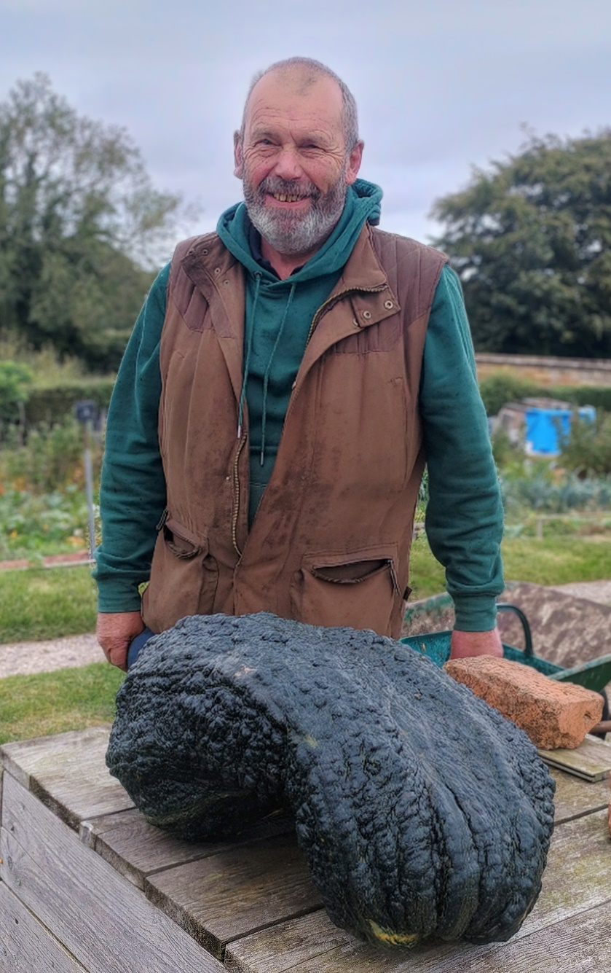
Brian and his winning marrow

